Assessment 2
Individual Report
Report: Forecasting report

DATA4400 Data-driven Forecasting

T3 2025-2026

Facilitator: Carlos Tapia

Isadora Faria
Student ID: 1857869

- Introduction

This report presents a time series forecasting analysis to support data-driven decisions within Cotton On Group. The objective of the study is to examine how forecasting can be used to improve operational planning in a real-word business scenario.

This project identifies key business challenges related to sales demand fluctuations and staff allocations and proposes time series forecasting as a solution. Using a monthly retail demand dataset and creating seasonal forecasting model, the study aims to evaluate future demand patterns and their implication for the business performance, generating actionable insights to improve planning and decision-making.

- Organisation Overview
Cotton On Group is an Australian-based fashion retail organisation operating across Australia and internationally through a wide range of physical stores as well as online retail platforms. The company offers accessible fashion products to a diverse customer base, with sales demand influenced by seasonal fluctuations, promotional cycles and customer behaviour.
In this context, effective workforce planning is essential to align staffing level with customer demand, especially during peak retail periods such as holidays, end of fiscal year sales, Christmas and Easter. The demand variability makes it challenging for managers to anticipate staffing requirements in an accurate manner.
Therefore, workforce management often remains reactive, with decisions guided by recent market trends rather than structured predictive analysis. This often results in labour imbalances, workforce shortages during peak and excess staffing during slower periods, contributing to high operational costs and low service quality. These observations demonstrate the value of implementing data-driven forecasting approaches for better workforce optimisation.

- Importance of Forecasting
Forecasting is essential for both strategic and operational planning, particularly in industries characterised by demand variability such as retail. Through the analysis of historical time series data, organisations are able to identify trend movements and seasonal cycles that support reliable future demand predictions. Hyndman and Athanasopoulos (2021) explain that forecasting enhances strategic planning by replacing reactive decision-making with proactive and data-driven decisions.

In retail operations, forecasting is essential to support effective alignment of organisational capacity with projected customer activity. According to Chopra and Meindl (2019), accurate demand projections strengthen operational performance by enabling proactive planning of staffing resources, inventory management and service functions, especially in markets influenced by seasonality and dynamic purchasing habits.
By integrating forecasting into workforce planning processes, helps organisations to anticipate demand variations proactively and mitigate inefficiencies associated with staffing misalignment. For instance, Zara uses demand forecasting methods to combine sales data with trend analysis to anticipate customer demands and adjust inventory levels, supporting fast operational decision-making and improved performance (Zara, n.d).

- Time Series Data
The time series dataset used in this project consists of monthly retail sales demand data for the Queensland region, covering the period from 2020 to 2025. The main variable represents the total monthly fashion retail sales demand, measured in AUS millions, reflecting fluctuations in consumer purchasing activity across retail operations. To enhance the analysis, supplementary variables were incorporated, including monthly growth rates. Year-on-year comparisons, 3-month moving averages, and seasonality indicators.
The dataset was carefully developed using official Australian retail turnover statistics as a benchmark, following extensive research to replicate realistic retail demand behaviour for Cotton On Group. This structured simulation was designed to reflect key retail demand characteristics, including recurring seasonal patterns and cyclical peaks.
Descriptive analysis indicates moderate variability in monthly demand levels, with periods of increased volatility during peak retail months in Queensland. The moving average helps to reduce short-term fluctuations in the data, making overall demand trend easier to observe, while growth rate measures show periods of faster increase or decrease in sales, providing insights in both short and long-term demand.
Overall, the dataset offers a strong basis for forecasting combining monthly sales demand with supporting variables of performance measures that can help to interpret changes in demand over time. This structured time series framework brings accurate projections and provides valuable insights for the company.

- Recommended Forecasting Technique
This study applies the Holt-Winters exponential smoothing model to forecast future demand, as it is designed handle time series data with trend and seasonal patterns commonly observed in the retail sector. The model incorporates level, trend and seasonality components that are regularly updated, enabling projections to adjust to shifts in market dynamics Hyndman and Athanasopoulos (2021).
The chosen method offers several advantages for this scenario because it produces smooth and stable forecasts that are suitable for operational planning, such as workforce allocation and scheduling. Rather than reacting strongly to short-term demand changes, Holt-Winters combines recent observations with long-term patterns while preserving forecast flexibility. The model also performs well with medium-sized time series datasets, making it appropriate for practical business scenarios. These qualities support consistent and reliable projections for decision-making purposes.

- Results and Analysis
The Holt-Winters forecast captures long-term growth as well as recurring seasonal fluctuations in monthly retail demand. The results show consistent peaks during December, with additional increase around easter and End of fiscal year sales in June. These cycles repeat annually, reflecting retail consumption habits.
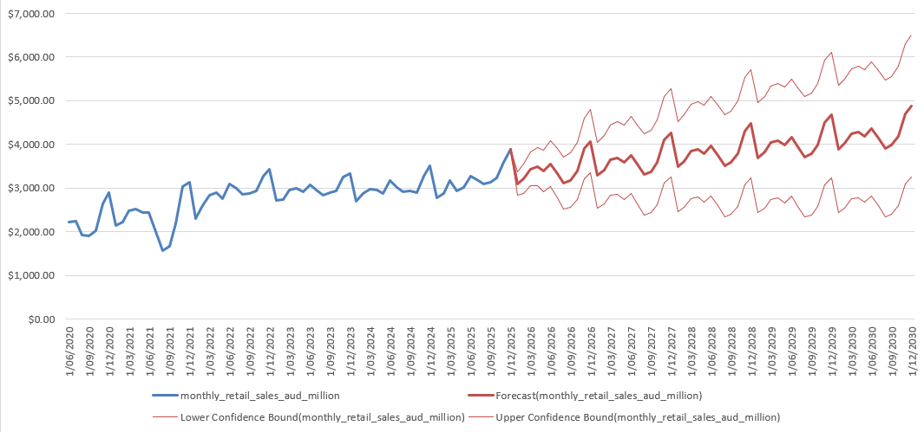
Image 1 – Holt-Winters Forecasting results

These recurring increases in projected retail demand indicate predictable periods of intense customer traffic and store activity, directly impacting staffing requirements. During these months, it would be required higher workforce capacity to maintain service quality and operational efficiency.
The expanding confidence intervals shows that forecasting uncertainty increases over time, reinforcing the use of short-term forecasting over the years for predicting staff scheduling while applying long-term projections.
The forecasting was limited to 2030 to ensure realistic and reliable demand projections based on historical patterns. Long-term forecasts can be uncertain, particularly when significant events may change existing demand behaviour. In Queensland scenario, major infrastructure investment development and population movement linked to the 2032 Summer Olympics are expected to influence economic conditions and impact retail demand behaviour.
Overall, the results serve as practical planning tool, enabling managers to anticipate staffing needs in advance and provide clear identification for proactive workforce hiring by identifying predictable seasonal peaks and long-term growth, enabling more efficient staff allocation.

- Operational Strategy and Business Benefits
Based on the results, a structured workforce strategy can be implemented over the next five years to align staffing with demand growth and seasonal fluctuations. During peak, particularly December, staffing levels should increase by approximately 20-25%, while Easter and EOFY that are moderate peaks would require about 12-18% workforce uplift. In lower-demand months, staffing levels can be reduced by 8-12% to optimise costs. During the year staff scheduling would be adjusted 4-6 weeks in advance based on short-term demand forecasts.
The proposed strategy is based on demand-driven scheduling principles widely applied in retail operations. Studies in retail workforce analytics indicate that combining staffing capacity with forecasted demand patterns enhances staff productivity, service quality and cost management (Fisher et al., 2010; Ton, 2012).
The company would implement targeted recruitment strategies focused on attracting people who seek casual and seasonal employment contracts. This can include university students, part-time workers seeking for extra jobs, candidates interested in short-term contracts only for high-demand retail periods.
By implementing this forecast-driven strategy, Cotton On Group would benefit from increased staff efficiency and greater cost control across five-year planning horizon. More accurate scheduling minimises las-minute roster changes and overtime expanses, helping with more stable staffing costs. In addition, having adequate number of staff during high-traffic periods enhances customer experience, conversion rates, better KPI’s and revenue maximization. Over time, this proactive approach strengthens operational performance and profitability within Queensland retail market.

- References

Hyndman, R.J., & Athanasopoulos, G. (2021) Forecasting: principles and practice, 3rd edition, OTexts: Melbourne, Australia. OTexts.com/fpp3. Accessed on 16/02/2026

Makridakis, S, Spiliotis, E & Assimakopoulos, V 2018, ‘Statistical and Machine Learning forecasting methods: Concerns and ways forward’, in AR Hernandez Montoya (ed.), PLOS ONE, vol. 13, no. 3, p. e0194889.

Fildes, R, Ma, S & Kolassa, S 2022, ‘Retail forecasting: Research and Practice’, International Journal of Forecasting, vol. 38, no. 4, pp. 1283–1318.

Fisher, ML, Raman, A & McClelland, AS 2000, ‘Rocket-science retailing is almost here: Are you ready?’

Madhani, PM 2021, ‘Deploying a “Good Jobs” Strategy in Service Sectors for Enhancing Competitive Advantage’, International Journal of Business Strategy and Automation, vol. 2, no. 1, pp. 29–53.

Brisbane 2032 Olympics 2024, Olympics.com.

